Locking finger – But not Trigger finger
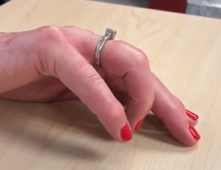
Finger locks at the PIP joint, flexion is initiated at DIP. Then the finger snaps into flexion.
Assess for A1 tenderness, if present it is a trigger finger. If not look for attenuation of the lateral bands.
Functional limitation: the finger is stuck in extension.
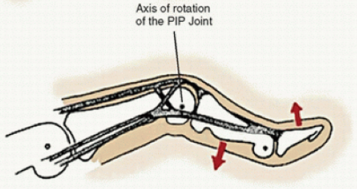
Suspect lateral band involvement/ attenuation.
When kept in 30 deg flexion the finger doesn't lock. The reasoning behind 30 deg flexion was to advance the lateral bands below the PIP joint axis, to make it work as a flexor. Full extension can cause it to lock and snap as the finger moves from extension to flexion.

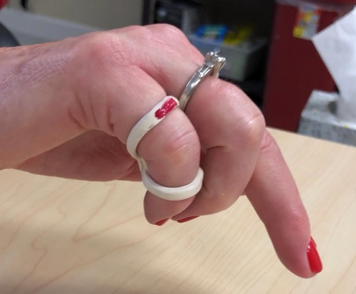
So, we provided the patient with a figure 8 splint. However, if the figure 8 loops were too close, it failed to correct the snapping in the finger as it allowed for too much extension. So, in order to keep the loops as far apart as possible to prevent full extension, use a strip and wrap around the intersection of the figure 8 loop. This keeps the loops apart and maintains the needed 30 deg flexion.
We used a nail polish on top for the patient to identify the proximal and distal ends.

